**NAME – GAJAPATI.VE.S**

**ROSHINI.S**

**SURYA.S**

**WASIUMDEEN.A**

**Literature Survey on Smart Water Quality Monitoring System**

**vaishnavi V, Varshitha R C, Tejaswini M, Needhu Rebecca Biju**

***Mr. Kumar K,***

*Assistant Professor K S Institute of Technology, Bangalore, India, 560062*

Abstract: Water is one of the major compounds that profoundly influence ecosystem. But, nowadays it is been exploited heavily due to rapid industrialization, human waste and random use of pesticides and chemical fertilizers in agriculture, which leads to water contamination. Thus, a water monitoring system is necessary to observe the water quality in a large area such as lake, river, and aquaculture. As per the current world situation, Internet of Things (IoT) and remote sensing techniques are used in heterogeneous areas of research for supervising, congregate and analyzing data from the remote locations. In this paper, the suggested system is a minimal price real time water quality monitoring system in IoT environment. This system comprise of numerous sensors for assessing the physical and chemical parameter. The factors of water that can be assessed using these sensors are pH, turbidity conductivity, dissolved oxygen. Using this system the real time quality of water bodies can be determined and the data uploaded over the Internet are analyzed.

Water quality, Internet of Things (IoT) Cloud, Wi-Fi, Water parameters key words

INTRODUCTION: india is facing a major issue of natural resource exiguity, especially in case of water due to population growth and economic development [4]. Most of the water bodies are contaminated due to the superfluous pollutants, which are mostly human-made. Thus certify the cleanliness of water is a major challenge. Rapid industrialization and greater emphasis on agriculture growth with latest technology, usage of more fertilizers and pesticides caused large impurity in aquatic surroundings directing to debasement of water quality and depletion of aquatic life [4]. Water bodies are contaminated due to point and non-point sources of pollution, which include sewage discharge, discharge from industries, run-off from agricultural fields, urban run-off and even due to floods, droughts and lack of education and awareness amid users [5]. The involvement of users in looking at the aspects like hygiene, environment sanitation, storage and disposal are exceptive elements to uphold the quality of water bodies The tonicity of lakes, rivers and other water bodies and their biological diversification are directly linked with the health of nearly every element of the ecosystem. Due to the use of befouled water by ecosystem components the waterborne diseases are spreading over surroundings causing death and slowing down socio-economic progress. About 5 million people have died because of water borne diseases all over the world (Water Resource Information System of India, 2017) [5]. Fertilizers and pesticides used for agriculture purpose can be washed by rain through soil, which ends up in water bodies

Table 1- Ideal water ranges in accordance with WHO standards

 There are various techniques to examine the quality of water. They are as given below:1.

work

*Autonomous water quality monitoring system using GSM*

*[8]*

 This system was established with the Autonomous Live Animal Response Monitor (ALARM) toxicity biosensor, aimed to be positioned in-stream forum interrupted surveillance. ALARM is developed at Victorian Centre for Aquatic Pollution Identification and Management (CAPIM). The aim is to develop a minimal cost, wireless water quality monitoring system that monitors the water conditions contiguously. The system measures a suite of physiochemical parameters like salinity, dissolved oxygen, temperature, intensity level,

pH, electrical conduction, total dissolved solids, and redox potential in fresh water. These parameters provides the present status of water conditions and assist in identifying pollution sources using low cost sensors and open source hardware at lower cost

*2. Use of image processing technology for water quality monitoring system*

*[9]*

In recent years the fish responding behavior has been considered as one of the approach for water quality monitoring. The system has been built by applying image processing and auto-recognition of the gesture of fish using fuzzy inference in water bodies. First the setting up of the image background model usingW4 method was done, and then deducted the background to recognize the fish profile. Once the center-of-gravity position of fish profile is found out the real time characteristic information of fish can be obtained such as position, moving track, speed. This information will be given as the input of fuzzy inference system, through appropriate rules in analyzing, the output value can be obtained. In this study, Zebra fish, Common Goldfish have been taken as the study objects via different devices into water and out of water along with discrete concentration of agent to observe the fish Smart Sensors for Real-Time Water Quality Monitoring using Zig Bee

[10]:

The system is skilled to measure the physiochemical parameters of water quality, such as flow temperature, pH, conduction, redox potential. These physiochemical parameters are used to identify water pollutants in rivers, lakes etc. The sensors are allied to a microcontroller-based assessing node, which processes and evaluates the data. In this scheme Zig Bee receiver and transmitter modules are used for inter connecting among the measuring and notification node. In this system, Zig Bee receiver and transmitter modules are used for communicating among the measuring and notification node. The warning hub displays the perusing of the sensors and yields a sound ready when the parameters achieve risky levels. Numerous qualification tests are been conducted to confirm each part

Smart water quality monitoring system using Wi-Fi the monitoring system. The sensors drive within their n be used by users including water authorities which help them to check up the water state As the values will be passed to users in ordered interim based on the scale defined for each parameter, users can have knowledge of about the water state. If the water is unhygienic then the related authorities can take measures needed to make the water clean and usable, even the society can take requisite measures in order to reduce the contaminants present in water. These measures can boost the water quality which makes it more us able

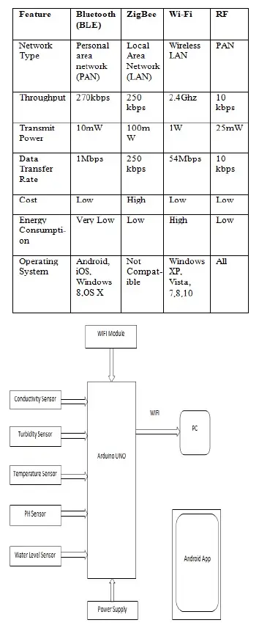

*Impact Factor Value 4.046*

 e-ISSN: 2456-3463

*International Journal of Innovations in Engineering and Science, Vol. 3, No.3, 2018*

*www.ijies.net*

23

precision ranges. The menstruation node transmits information using Zig Bee towards the notification node for displaying the audio and visual information The result shows that the approaches the ability to read physiochemical parameters, and is capable of processing, transmission, and exhibiting the readings.

*4. Smart water quality monitoring system using Wi-Fi:*

Impact Factor Value 4.046

e-ISSN: 2456-3463

International Journal of Innovations in Engineering and Science, Vol. 3, No.3, 2018

www.ijies.net

23

precision ranges. The menstruation node transmits information using Zig Bee towards the notification node for displaying the audio and visual information The result shows that the approaches the ability to read physiochemical parameters, and is capable of processing, transmission, and exhibiting the readings.

4. Smart water quality monitoring system using Wi-Fi:

Fig1:Block diagram of the system using Wi-Fi module The crucial parameters that are supervised by the system are conductivity, temperature, water level, pH and turbidity. Fig 1 illustrates the block diagram of the inclusive real time water quality monitoring system in IoT environs.[7] In this system, the sensors such as conductivity temperature, water level, pH, turbidity sensor with a Wi-Fi module and a power supply is allied to the basic controller- Aruduino UNO. The basic controller retrieves the sensor values which will be assessed by situating the sensors in distinct water samples and the data will be directed to the cloud by means of the WI-FI module. An android application recommended will be used to reveal the sensor values examined via cloud and warnings will be provided to user if the value outstrips the threshold value. The application